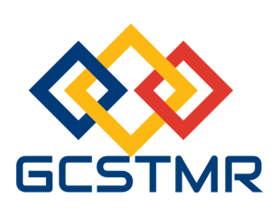
Global Circle for Scientific, Technological and Management Research (GCSTMR)
http://www.gcstmr.com.au
12 Boyer Pl, Minto, NSW 2566, Sydney, Australia
==========================================================
1st International Conference on Business Research and Ethics (iCBRE2017)
20-22 November 2017, Sydney, Australia
(REGISTRATION FORM)
Please complete this registration form and email the completed form to secretary@gcstmr.com.au. A receipt of payment will then be emailed to you.
Paper ID
Paper Title
Registrant details | Name:  Address:  Email:  Contact Telephone No:
Registration Type (Please tick) | - Full registration - Early bird: $795 Bird on time: $850  - Student registration - Early bird: $450 Bird on time: $550  - Daily registration (for one day) - Early bird: $400 Bird on time: $450  - Accompanying family member - Early bird: $300 Bird on time: $350  Full registration fee includes the conference dinner.  Student registration, daily registration and accompanying family member registration rate do not include conference dinner. If you are registering in these categories, you need to pay $100 per person for attending the conference dinner.  - Conference dinner: $100  Early bird rate closes on 30 Sep 2017. Bird on time closes on 15 Nov 2017.  No on-site registration is allowed.
Total Amount paid
Registration date
(For daily registrant)
Transaction ID
(Payment details)

